**SYNOPSIS**

**Report on**

**SENTIMENT ANALYSIS**

**(FACE EMOTION DETECTION)**

**by**

GARGI AGARWAL 2000290140046

PINKUSH GUPTA 2000290140084

SOYAB KHAN 2000290140124

**Session:2021-2022 (4th Semester)**

Under the supervision of

**Prof. Ms. Vidushi (Assistant Professor)**

### KIET Group of Institutions, Delhi-NCR, Ghaziabad



### Department Of Computer Applications

**KIET GROUP OF INSTITUTIONS, DELHI-NCR, GHAZIABAD-201206**

(march- 2022)

**TITLE: SENTIMENT ANALYSIS (FACE EMOTION DETECTION)**

**ABSTRACT**

Emotion recognition plays a crucial role in the era of Artificial intelligence. It offers tremendous scope to human computer interaction, robotics, health care, biometric security and behavioural modelling. Emotion recognition systems recognize emotions from facial expressions, text data, body movements, voice, brain or heart signals. Along with basic emotions, attitude, control over emotions and power of activation of emotion can also be examined for analysing sentiments. A picture portrays much more than its equivalent textual description. Facial expression recognition is a basic process performed by every human every day. Each one of us analyses the expressions of the individuals we interact with, to understand best their response to us. Emotion recognition is the study of recognizing six universal expressions (anger, joy, fear, happiness, sadness and surprise) using various computer science techniques. On a day-to-day basis, humans commonly recognize emotions by characteristic features displayed as part of a facial expression. For instance, happiness is undeniably associated with a smile, or an upward movement of the corners of the lips. This could be accompanied by upward movement of the cheeks and wrinkles directed outward from the outer corners of the eyes. Similarly, other emotions are characterized by other deformations typical to the particular expression.

Keywords: Sentiment analysis, Emotion Recognition, Facial Expression Recognition.

**TABLE OF CONTENTS**

1. Abstract 2
2. Introduction 4
3. Literature Review 5
4. Project / Research Objective 6
5. Research Methodology 7
6. Project / Research Outcome 8
7. Proposed Time Duration 9
8. References 10

**INTRODUCTION**

Emotion recognition is the study of recognizing six universal expressions (anger, joy, fear, happiness, sadness and surprise) using various computer science techniques. As emotions reflect one’s state of mind by his/her unintentional actions that may or may not be paralinguistic. Human face detection (emotion) improved the human-computer interaction. In virtual environments, students’ emotional data can be obtained from a series of video frames. Therefore, to achieve real time understanding of students’ emotions, accuracy and time needs to be balanced. To improve accuracy, more video frames are required, increasing computation time. On the other hand, in pursuit of efficiency, we would reduce the accuracy which means collection less feature data. Emotion recognition has wide scope in many areas such as human computer interaction, biometric security etc. So it provides insight into artificial intelligence or machine intelligence that uses various supervised and unsupervised machine-learning algorithms to simulate the human brain. It was explored that study of human emotions, their interpretation, processing and adaptation by machines is known as affective computing or artificial emotional intelligence [18]. Human emotional state can be recognized from facial expressions, body movements, speech, text writing, brain or heart signals etc. using various machine learning techniques that extract required features or patterns from the collected data.

**LITERATURE REVIEW**

As described in introduction, there are five basic emotions: happiness, sadness, fear, anger and neutral which were recognized from multiple body movements such as head region, joints, upper and lower body movements, arm bound space to improve the accuracy of emotion recognition system. They have used video datasets to extract motion or kinetic features from speed, space, and symmetry of various body parts under three scenarios as walking, sitting and action independent cases. Thus it can be seen that the feature extraction framework has better understanding of emotions than human beings. Future scope stated in the paper are 1) Along with the body movements, voice and facial expressions can also be taken to improve the performance because action independent scenarios give less accuracy 2) Enhancement in tools to improve communication between human and robots 3) Remote sensing of emotions in case of emergency 4) To implement better tools for training programs in medical rehabilitation centers. 5) Recognizing emotions from body movements is yet to be explored more.

**PROJECT OBJECTIVE**

Through this project we would achieve the objective of analysing the emotion of the persons through video (webcam). These analysed emotion would be used in predicting the attentiveness in the virtual environment and also be used for security purpose.

Future scope of the project are:

1) Along with the body movements, voice and facial expressions can also be taken to improve the performance because action independent scenarios give less accuracy

2) Enhancement in tools to improve communication between human and robots

3) Remote sensing of emotions in case of emergency

4) To implement better tools for training programs in medical rehabilitation centres.

5) Recognizing emotions from body movements is yet to be explored more.

**RESEARCH METHODOLOGY**

In this work, we explore the impact of visual modality in addition to speech and text for improving the accuracy of the emotion detection system. The traditional approaches tackle this task by fusing the knowledge from the various modalities independently for performing emotion classification.

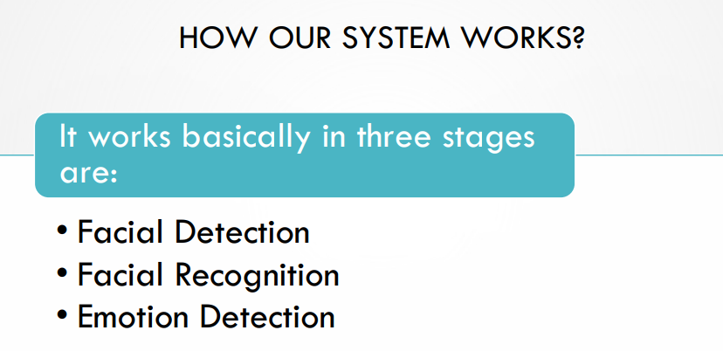

**RESEARCH OUTCOME**

Proposed research work is elaborated using Machine Learning, to calculate the efficiency of proposed techniques with existing techniques in the terms of.

➢ Accuracy

➢ Predicting rate

➢ Severity

➢ Sensitivity

➢ Specificity

**PROPOSED TIME**

Proposed time duration for this work 1.5 months.

**REFERENCES**

1. Sukhpreet Kaur1 , Nilima Kulkarni2; “Emotion Recognition – A review” ; International Journal of Applied Engineering Research ISSN 0973-4562 Volume 16, Number 2 (2021) pp. 103-110.

2. Mrs. Ayesha Butalia, Dr. Maya Ingle, Dr. Parag Kulkarni; “Facial Expression Recognition for Security”; International Journal of Modern Engineering Research (IJMER) Vol.2, Issue.4, July-Aug 2012 pp-1449-1453.

3. F. Ahmed, MSA. Hossain Bari, ML. Gavrilova, “Emotion Recognition From Body Movement”, IEEE Access 8, doi 10.1109/access.2019.2963113, 2020, pp. 11761-11781.

4. MA. Nicolaou, S. Zafeiriou, I. Kotsia, G. Zhao, J. Cohn, “Editorial of Special Issue on Human Behaviour Analysis “In-the-Wild”, IEEE Transactions on Affective Computing 10:4-6. doi 10.1109/TAFFC.2019.2895141, 2019.

5. J. Guo, Z. Lei, J. Wan, E. avots, N. hajarolasv, B. knyazev, A. et. al, “Dominant and Complementary Emotion Recognition From Still Images of Faces”, IEEE Access 6, doi 10.1109/ACCESS.2018.2831927, 2018, pp. 26391-26403.

6. CA. Corneanu, M. Oliu, JF. Cohn, S. Escalera, “Survey on RGB, 3D, Thermal, and Multimodal Approaches for Facial Expression Recognition: History, Trends, and Affect-related Applications”, IEEE Transactions on Pattern Analysis and Machine Intelligence, doi 10.1109/TPAMI.2016.2515606, 2015.

7.W. Wei, Q. Jia, Y. Feng, G. Chen, M. Chu, “Multimodal facial expression feature based on deep-neural networks”, Journal on Multimodal User Interfaces. doi https://doi.org/10.1007/s12193-019-00308-9, 2020, pp. 17-23.

8. MS. Hossain, G. Muhammad, “Emotion Recognition Using Deep Learning Approach from Audio-Visual Emotional Big Data”, Information Fusion, doi: https://doi.org/10.1016/j.inffus.2018.09.008, 2018.